
Faculty of Science

Course: CSCI 2020u – Software System Development & Integration
Component: Assignment
Weight: 10%
Deadline: March 5, 2020 (due by 11:59pm)

Collaboration Policy
You are permitted to work on this assignment in a team, and submit the results as a team. For this sort of assignment, with an open-ended component, the collaboration between multiple team members can be beneficial. Between groups, however, please limit the discussion to the level of general strategy (not code). Groups of size 2 are recommended. Larger groups will be considered with the proviso that the marker will mark your assignment with higher expectations. In any case, be sure that all members of the team fully understand all code, otherwise they will miss intended learning objectives, which may be a considerable disadvantage at exam time.

How to Submit
You will maintain a git repository for this assignment, which is a public repository. To submit the assignment, create a single file ‘README.txt’ that contains instructions on how to download, compile, and run your codes for each question. A .zip, .7z, or .rar file will not be acceptable. Also submit this word file (once you complete) into related drop box on Blackboard before deadline.

Note: Comments are mandatory. Failure to properly document your program will result in a deduction on the marks you receive for this (and any other) assignment.

Remember:
You need to complete this file and submit it in related drop box on Blackboard, in addition to uploading your codes in your git repository, before deadline.

Question 1: Displaying Three Cards

Problem Description:
Display a frame that contains three labels. Each label displays a card, as shown in the figure below. The card image files are named 1.png, 2.png, ..., 54.png and stored in the image/card directory. All three cards are distinct and selected randomly.

The image icons can be found in the attached card folder.

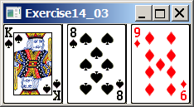

Your Task:
- Create three ImageView and set their icons using the images.
- Display three images from 54 image cards randomly.

Your Code:
Copy-paste your code here:

package sample;
import java.util.ArrayList;
import java.util.Random;
import javafx.application.Application;
import javafx.geometry.Pos;
import javafx.scene.Scene;
import javafx.scene.image.Image;
import javafx.scene.image.ImageView;
import javafx.scene.layout.HBox;
import javafx.stage.Stage;
public class Main extends Application {
static String path = "file:D:\\Uoit\\Uoit Second year\\Second Sem\\Software Dev and Integ\\Assignemnt\\src\\sample\\Cards", fileExt = ".png";
//declaring an array of cards
Image cards[];
@Override
public void start(Stage primaryStage) {
//This will initialize the array of cards
cards = new Image[54];
//the following piece of coding is to load the cards
for (int i = 0; i < cards.length; i++) {
cards[i] = new Image(path
+ (i + 1) + fileExt, true);
}
Random random = new Random(); //The following line of code will define a random number generator
HBox row = new HBox(); //defining an hbox to arrange all of the elements in the array for cards
row.setAlignment(Pos.CENTER);
// defining a list containing 3 unique random index between 0 and 52,
ArrayList<Integer> Rand_index = new ArrayList<>();
while (Rand_index.size() != 3) {
int randomCard_Ind = random.nextInt(cards.length - 2);
if (!Rand_index.contains(randomCard_Ind)) {
Rand_index.add(randomCard_Ind);
}
}
for (Integer randomCard_Ind : Rand_index) {
ImageView im = new ImageView(cards[randomCard_Ind]);
row.getChildren().add(im);
}
Scene scene = new Scene(row, 300, 120);
primaryStage.setTitle("Question_1");
primaryStage.setScene(scene);
primaryStage.show();
}
public static void main(String[] args) {
launch(args);
}
}

Screen shots:
Include two screen shots here:

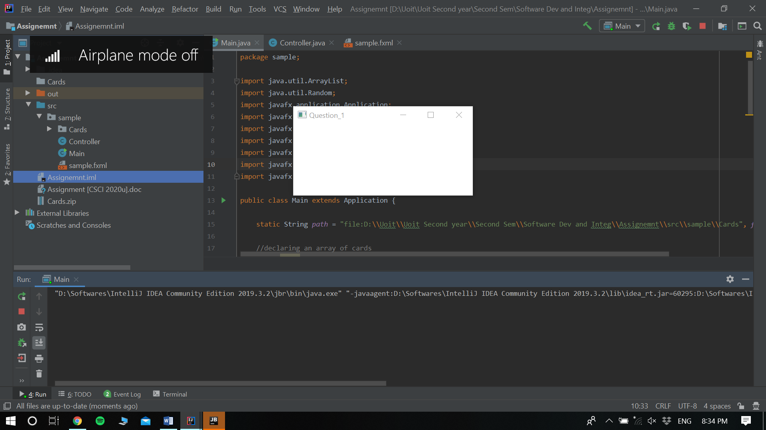

Question 2: Investment-Value calculator

Problem Description:
Write a program that calculates the future value of an investment at a given interest rate for a specified number of years. The formula for the calculation is as follows:

futureValue = investmentAmount * (1 + monthlyInterestRate)years*12

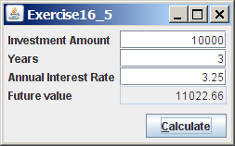

Your Task:
Use text fields for interest rate, investment amount, and years. Display the future amount in a text field when the user clicks the Calculate button, as shown in the figure.

Your Code:
Copy-paste your code here.

package sample;
import javafx.application.Application;
import javafx.scene.Scene;
import javafx.scene.control.TextField;
import javafx.scene.control.Button;
import javafx.scene.control.Label;
import javafx.scene.layout.GridPane;
import javafx.geometry.Pos;
import javafx.geometry.HPos;
import javafx.geometry.Insets;
import javafx.stage.Stage;
public class Main extends Application {
private TextField Investing_amount = new TextField();
private TextField No_of_years = new TextField();
private TextField int_rate = new TextField();
private TextField text_finalValue = new TextField();
private Button calc_button = new Button("Calculate");
@Override
public void start(Stage primaryStage) {
GridPane pane = new GridPane();
pane.setVgap(5);
pane.setHgap(5);
pane.add(new Label("Investment Amount:"), 0, 0);
pane.add(Investing_amount, 1, 0);
pane.add(new Label("Number Of Years:"), 0, 1);
pane.add(No_of_years, 1, 1);
pane.add(new Label("Annual Interest Rate:"), 0, 2);
pane.add(int_rate, 1, 2);
pane.add(new Label("Future value:"), 0, 3);
pane.add(text_finalValue, 1, 3);
pane.add(calc_button, 1, 4);
pane.setAlignment(Pos.CENTER);
Investing_amount.setAlignment(Pos.BOTTOM_RIGHT);
No_of_years.setAlignment(Pos.BOTTOM_RIGHT);
int_rate.setAlignment(Pos.BOTTOM_RIGHT);
text_finalValue.setAlignment(Pos.BOTTOM_RIGHT);
text_finalValue.setEditable(false);
GridPane.setHalignment(calc_button, HPos.RIGHT);
pane.setPadding(new Insets(10, 10, 10, 10));
calc_button.setOnAction( W-> final_val());
Scene scene = new Scene(pane);
primaryStage.setTitle("Question_2"); // This line of coding will set the stage title
primaryStage.setScene(scene); // This line of coding will place the scene in the stage
primaryStage.show(); // This line of coding will display the stage
}
//This function calculates the final value that is needed in order to get the "Future value"
private void final_val() {
double invest_Amount = Double.parseDouble(Investing_amount.getText());
int year_no = Integer.parseInt(No_of_years.getText());
double month_interest =
Double.parseDouble(int_rate.getText()) / 1200;
text_finalValue.setText(String.format("$%.2f",
(invest_Amount * Math.pow(1 + month_interest, year_no * 12))));
}
}

Screen shots:
Include two screen shots here:

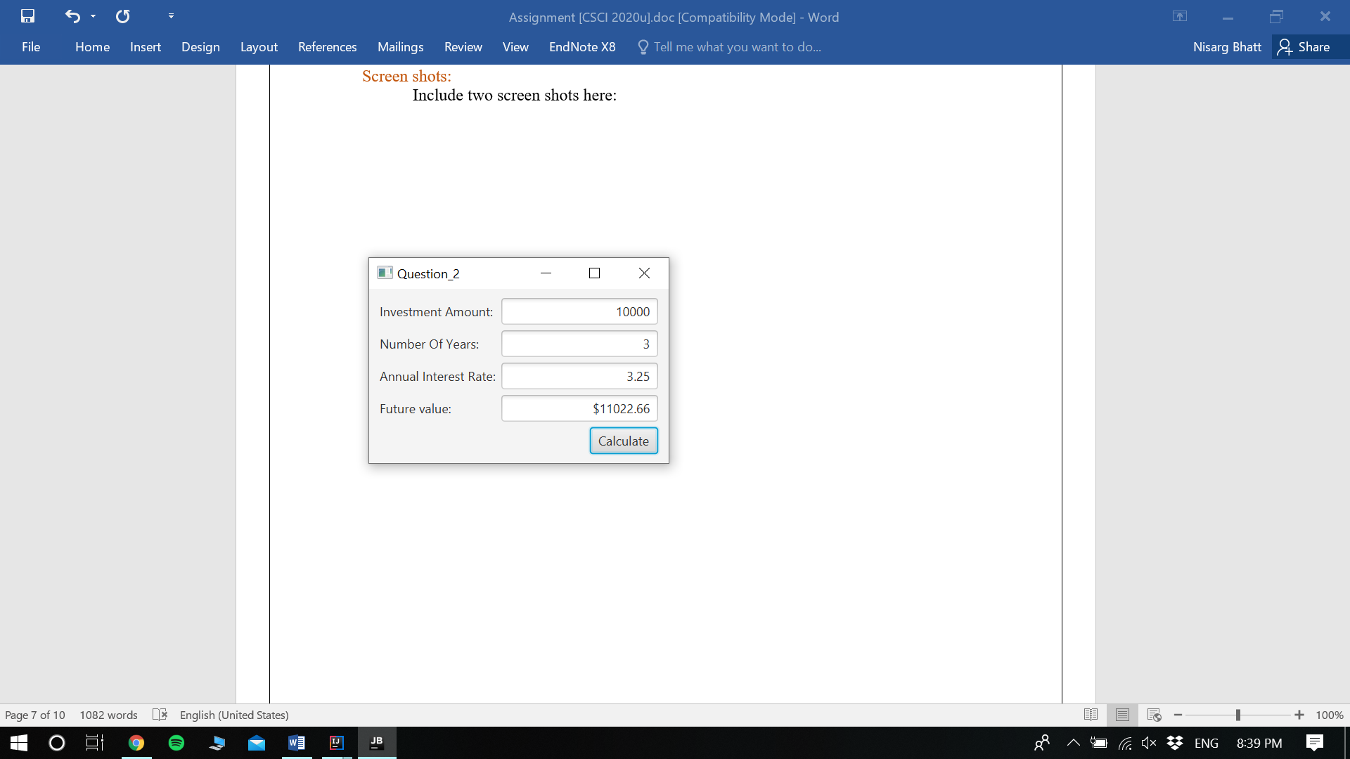
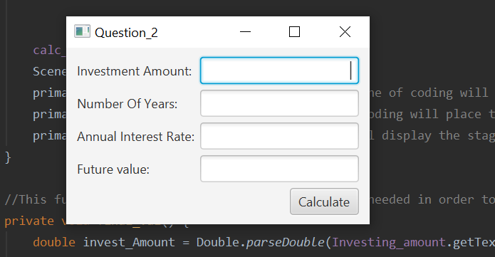
Question 3: Dragging Points on a Circle

Problem Description:
Draw a circle with three random points on the circle. Connect the points to form a triangle. Display the angles in the triangle. Use the mouse to drag a point along the perimeter of the circle. As you drag it, the triangle and angles are redisplayed dynamically.

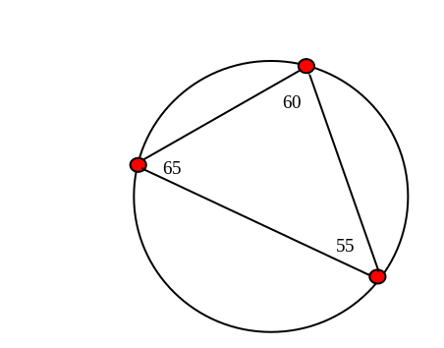

Here is the formula to compute angles:

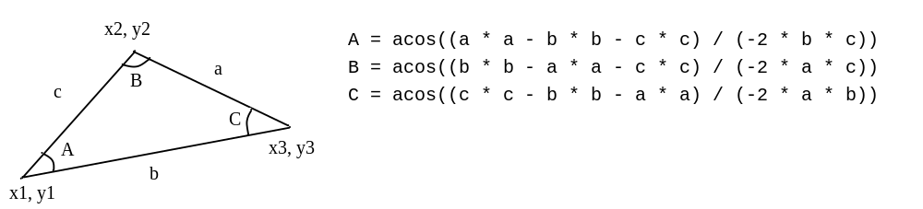

Your Code:
Copy-paste your code here:

package sample;
import java.awt.Point;
import javafx.application.Application;
import javafx.scene.Scene;
import javafx.scene.input.MouseEvent;
import javafx.scene.layout.Pane;
import javafx.scene.paint.Color;
import javafx.scene.shape.Circle;
import javafx.scene.shape.Line;
import javafx.scene.text.Text;
import javafx.stage.Stage;
public class Main extends Application {
//Defining all the necessary variables that are needed in order to make the program run
private Circle draw_circle; //big circle
private Circle first_point, second_point, third_point;//points
private Line first_line, second_line, third_line; //lines to connect points
private Text angle_one, angle_two, angle_three; //to display angles between points
@Override
public void start(Stage primaryStage) {
draw_circle = new Circle(200);
draw_circle.setCenterX(250);
draw_circle.setCenterY(250);
draw_circle.setFill(Color.TRANSPARENT);
draw_circle.setStroke(Color.BLACK);
//initializing three small red circles to represent points
first_point = new Circle(10);
first_point.setFill(Color.RED);
first_point.setStroke(Color.BLACK);
//passing the point object and mouse event object after adding a mouse dragged listener which will allow
//to call the movepoint() method later on
first_point.setOnMouseDragged(D -> movePoint(first_point, D));
second_point = new Circle(10);
second_point.setFill(Color.RED);
second_point.setStroke(Color.BLACK);
second_point.setOnMouseDragged(D -> movePoint(second_point, D));
third_point = new Circle(10);
third_point.setFill(Color.RED);
third_point.setStroke(Color.BLACK);
third_point.setOnMouseDragged(D -> movePoint(third_point, D));
initialize(); //initializes the default view and all three angles
update(); //this method will update the view
//the following line of coding creates pane and adds everything in the order
Pane root = new Pane(draw_circle, first_line, second_line, third_line, angle_one, angle_two,
angle_three, first_point, second_point, third_point);
Scene scene = new Scene(root, 500, 500);
primaryStage.setScene(scene);
primaryStage.setTitle("Question_3");
primaryStage.show();
}
//this will initialize all the values regarding default_values
void initialize() {
//this will initialize the text to display angles
angle_one = new Text();
angle_two = new Text();
angle_three = new Text();
//The following piece of code finds the radius of the circle
double X_center = draw_circle.getCenterX();
double Y_center = draw_circle.getCenterY();
double radius = draw_circle.getRadius();
double angle = 0;
double x = X_center + radius * Math.cos(Math.toRadians(angle));
double y = Y_center + radius * Math.sin(Math.toRadians(angle));
first_point.setCenterX(x);
first_point.setCenterY(y);
//The following piece of code will find the coordinates of the point to show the angle
//same thing as above, difference is the distance from center
x = X_center + (radius - 50) * Math.cos(Math.toRadians(angle));
y = Y_center + (radius - 50) * Math.sin(Math.toRadians(angle));
angle_one.setLayoutX(x);
angle_one.setLayoutY(y);
angle = 90;
x = X_center + radius * Math.cos(Math.toRadians(angle));
y = Y_center + radius * Math.sin(Math.toRadians(angle));
second_point.setCenterX(x);
second_point.setCenterY(y);
x = X_center + (radius - 50) * Math.cos(Math.toRadians(angle));
y = Y_center + (radius - 50) * Math.sin(Math.toRadians(angle));
angle_two.setLayoutX(x);
angle_two.setLayoutY(y);
angle = 180;
x = X_center + radius * Math.cos(Math.toRadians(angle));
y = Y_center + radius * Math.sin(Math.toRadians(angle));
third_point.setCenterX(x);
third_point.setCenterY(y);
x = X_center + (radius - 50) * Math.cos(Math.toRadians(angle));
y = Y_center + (radius - 50) * Math.sin(Math.toRadians(angle));
angle_three.setLayoutX(x);
angle_three.setLayoutY(y);
//The following small piece of code will just connect the lines
first_line = new Line(first_point.getCenterX(), first_point.getCenterY(), second_point.getCenterX(), second_point.getCenterY());
second_line = new Line(second_point.getCenterX(), second_point.getCenterY(), third_point.getCenterX(), third_point.getCenterY());
third_line = new Line(third_point.getCenterX(), first_point.getCenterY(), first_point.getCenterX(), first_point.getCenterY());
}
//the following method will update the coordinates to the point where the mouse is dragged
void movePoint(Circle point, MouseEvent event) {
//finding current point and center point's location
double x1 = event.getX();
double x2 = draw_circle.getCenterX();
double y1 = event.getY();
double y2 = draw_circle.getCenterY();
//finds angle between current point and the center
double angle = Math.atan2(y1 - y2, x1 - x2);
double newX = x2 + draw_circle.getRadius() * Math.cos(angle);
double newY = y2 + draw_circle.getRadius() * Math.sin(angle);
point.setCenterX(newX); //sets the location of the points
point.setCenterY(newY); //sets the location of the points
//similarly updating the coordinates of the angle display text
newX = x2 + (draw_circle.getRadius() - 50) * Math.cos(angle);
newY = y2 + (draw_circle.getRadius() - 50) * Math.sin(angle);
if (point.equals(first_point)) {
angle_one.setLayoutX(newX);
angle_one.setLayoutY(newY);
} else if (point.equals(second_point)) {
angle_two.setLayoutX(newX);
angle_two.setLayoutY(newY);
} else {
angle_three.setLayoutX(newX);
angle_three.setLayoutY(newY);
}
update();//this will update the view
}
//The following method just updates the view
void update() {
//the following piece of code just reconnects all the lines
first_line.setStartX(first_point.getCenterX());
first_line.setStartY(first_point.getCenterY());
first_line.setEndX(second_point.getCenterX());
first_line.setEndY(second_point.getCenterY());
second_line.setStartX(second_point.getCenterX());
second_line.setStartY(second_point.getCenterY());
second_line.setEndX(third_point.getCenterX());
second_line.setEndY(third_point.getCenterY());
third_line.setStartX(third_point.getCenterX());
third_line.setStartY(third_point.getCenterY());
third_line.setEndX(first_point.getCenterX());
third_line.setEndY(first_point.getCenterY());
//The following line of code will find the distance between the second and the third point
double a = Point.distance(second_point.getCenterX(), second_point.getCenterY(), third_point.getCenterX(), third_point.getCenterY());
//The following line of code will find the distance between the first and the third point
double b = Point.distance(first_point.getCenterX(), first_point.getCenterY(), third_point.getCenterX(), third_point.getCenterY());
//The following line of code will find the distance between the second and the first point
double c = Point.distance(second_point.getCenterX(), second_point.getCenterY(), first_point.getCenterX(), first_point.getCenterY());
//the following piece of code was given in the given document to calculate the angles
double angle1 = Math.acos((a * a - b * b - c * c) / (-2 * b * c));
double angle2 = Math.acos((b * b - a * a - c * c) / (-2 * a * c));
double angle3 = Math.acos((c * c - b * b - a * a) / (-2 * a * b));
//The following piece of code will find the angles to one decimal precision as the user decides to drag it
angle_one.setText(String.format("%.1f", Math.toDegrees(angle1)));
angle_two.setText(String.format("%.1f", Math.toDegrees(angle2)));
angle_three.setText(String.format("%.1f", Math.toDegrees(angle3)));
}
public static void main(String[] args) {
launch(args);
}
}

Screen shots:
Include two screen shots here:

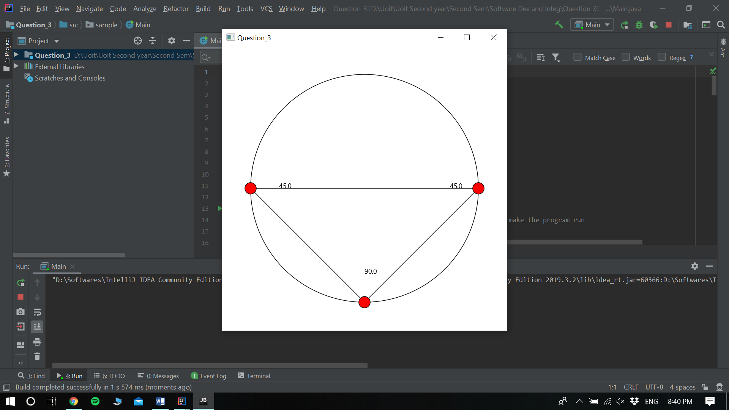

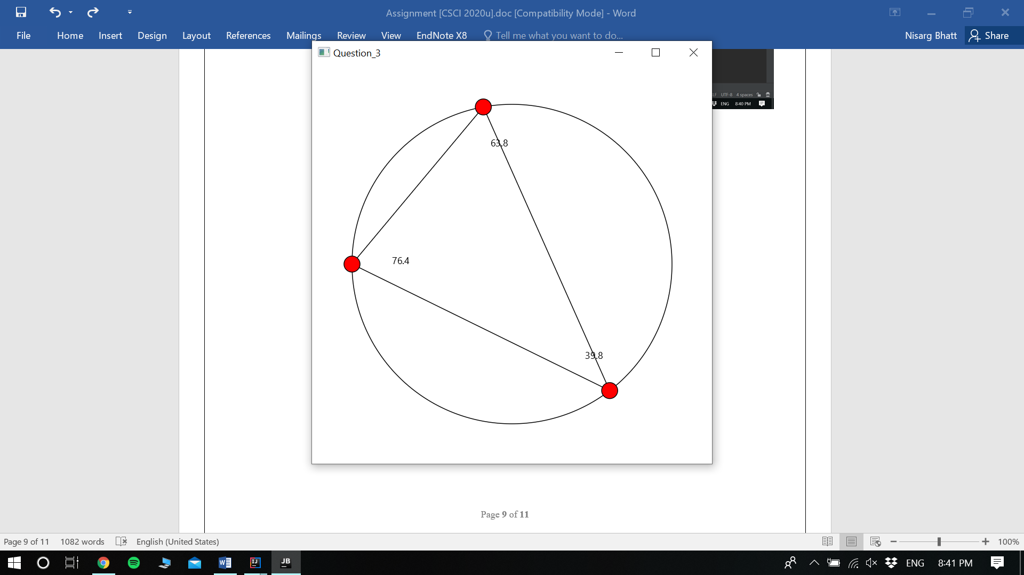
Question 4: Histogram

Problem Description:
Develop a program that displays a histogram to show the occurrences of each letter in a text area. The histogram should show the occurrences of each letter in a text file, as shown in the following figure. Assume that the letters are not case sensitive.

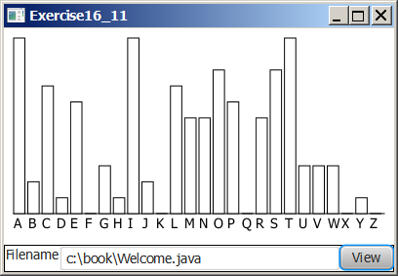

Your Task:
- Place a pane that will display the histogram in the center of the frame.
- Place a label and a text field in a panel, and put the panel in the south side of the frame. The text file will be entered from this text field.
- Pressing the Enter key on the text field causes the program to count the occurrences of each letter and display the count in a histogram.

Your Code:
Copy-paste your code here:

package sample;
import javafx.application.Application;
import javafx.scene.Scene;
import javafx.scene.control.Button;
import javafx.scene.control.ContentDisplay;
import javafx.scene.control.Label;
import javafx.scene.control.TextField;
import javafx.scene.layout.HBox;
import javafx.scene.layout.Pane;
import javafx.scene.layout.VBox;
import javafx.stage.Stage;
public class Main extends Application {
Pane pane = new Pane();
TextField file_text_field = new TextField();
VBox box = new VBox();
@Override
public void start(Stage primaryStage) throws Exception {
Label file_labelName = new Label("Filename:", file_text_field);
file_labelName.setContentDisplay(ContentDisplay.RIGHT);
file_text_field.setPrefColumnCount(20);
Button btView = new Button("View");
HBox hBox = new HBox(file_labelName, btView);
box.getChildren().addAll(pane, hBox);
Scene scene = new Scene(box);
primaryStage.setScene(scene);
btView.setOnAction(e-> {
box.setTranslateY(10);
primaryStage.sizeToScene();
});
primaryStage.show();
primaryStage.setTitle("Question_4");
}
public static void main(String[] args) {
launch(args);
}
}

Screen shots:
Include two screen shots here:
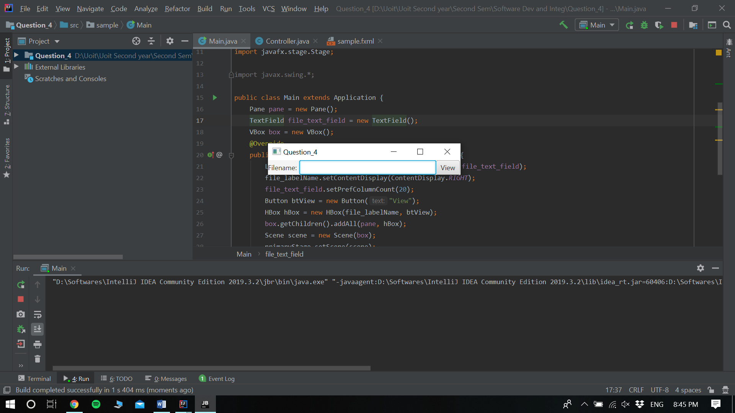
Remember:

You need to complete this file and submit it in related drop box on Blackboard, in addition to uploading your codes in your git repository, before deadline.

